Beholder’s Almanac

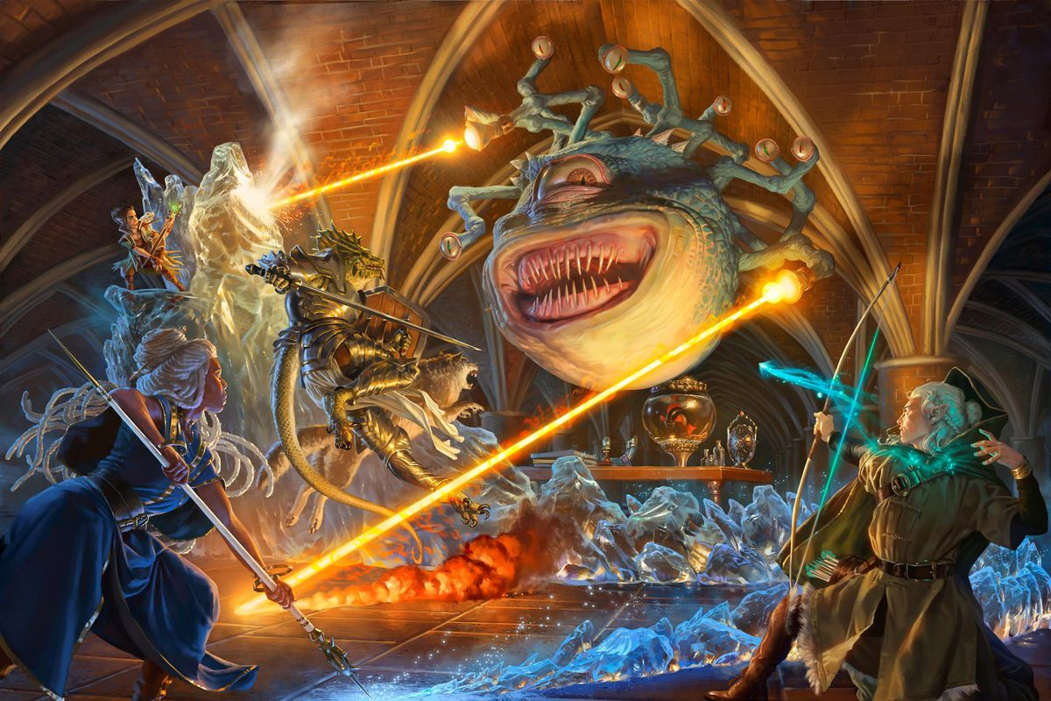

Source: <https://www.polygon.com/23023498/hasbro-buys-dnd-beyond-pdf-wotc-fandom>

Contents

1. Project Level Summary Evaluation - Requirements 4

2. IEEE 830 Software Requirements Specifications 4

2.1 Introduction 4

2.1.1 Purpose 5

2.1.2 Document Conventions 5

2.1.3 Intended Audience and Reading Suggestions 5

2.1.4 Product Scope 5

2.1.5 References 5

2.2 Overall Description 6

2.2.1 Product Perspective 6

2.2.2 Product Functions 6

2.2.3 User Classes and Characteristics 6

2.2.4 Operating Environment 6

2.2.5 Design and Implementation Constraints 7

2.2.6 User Documentation 7

2.2.7 Assumptions and Dependencies 7

2.3 External Interface Requirements 7

2.3.1 User Interfaces 7

2.3.2 Hardware Interfaces 8

2.3.3 Software Interfaces 8

2.3.4 Communications Interfaces 8

2.4 System Features 8

2.4.1 System Feature #1 (Character Sheet) 8

2.5 System Feature #2 (Dice Roller) 8

2.6 Other Nonfunctional Requirements 8

2.6.1 Performance Requirements 8

2.6.2 Portability 9

2.6.3 Security Requirements 9

2.6.4 Software Quality Attributes 9

2.6.5 Business Rules 9

Appendix A: Glossary 9

Appendix B: Use Case Diagram 10

**Appendix C: To Be Determined List 10

Appendix D: Project Plan 10

# Project Level Summary Evaluation - Requirements

What would you do better or differently?

* Digitize the experience via mobile app
* Ease of access for all ages
* Simplify complex rules using built in macros

What was the quality of the tools and techniques?

* Primary tool used is Microsoft office. Text is properly formatted.

Are the requirements clear?

* Requirements listed:
  + Android application
  + Information sheet functionality
  + Dice roller function
* General asset requirements listed

What are the strengths and weaknesses?

* Strengths
  + Easy to understand
  + Clear outline of project
  + User-base is wide and has large market share
* Weaknesses
  + Design schema unclear
  + Make be unclear to those unfamiliar with tabletop roleplaying games

What are your recommendations or suggestions?

* Screenshots of the project outline would be helpful
* A design schema showing the functional

# IEEE 830 Software Requirements Specifications

## Introduction

Created by Ernest Gygax and David Arneson, Dungeons and Dragons debuted 1974 as a fantasy role-playing game with over 50 million players since its release. With a game that was released before the VHS was established there have been numerous updates and quality of life adjustments over the life of the game. But to its core the game is still a pencil and paper game with dice as its core mechanic. The issue arises as games become more complicated, characters have more stats and enemies become more numerous keeps tracking of all these things with just a pencil and paper can at times feel antiquated and clunky. Making sure you’re properly keeping track of all of this can take away from the purpose of the game, the roleplaying.

### Purpose

2,500,000,000. There are over 2.5 billion active Android users worldwide, with more than 3 million devices across the globe using the Android operating system. You will be hard pressed to find someone that doesn’t always have a smart phone in their pocket. The solution is to create a mobile app that takes away a lot of the inconvenience and clunkiness of pencil and paper and puts the work and functionality in the hands of the end-user utilizing a mobile app to track character sheet information and added functionality of a dice roller.

### Document Conventions

Bolded words or phrases will be used to indicate features of the project. Italics will be used to indicate user interactions. Under-lined sections are to indicate features or tools yet to be implemented.

### Intended Audience and Reading Suggestions

The intended audience for D&D podcasts is people who are considering venturing into playing Dungeons and Dragons or who are already playing. The application can also be used be anyone who has a need for a dice roller for any tabletop game.

### Product Scope

The main deliverable for this project is a working Android application that will allow an end user to input information to create their character sheet. This should show the character’s name, hit points, speed, armor, initiative, and main stats (e.g., Strength, Intelligence, Dexterity… etc.) Ideally I want the character sheet to be updated easily with new information and display the updated information quickly. The second function of the app is to act as a random dice roller. I want the function to allow the user to select how many sides the dice has (e.g., 4,6,20, 100 etc.) as well as how many dice should be rolled at once. The function should be able to display each dice individually and display a total output sum of the dice if multiple is rolled at once. To accomplish this there will be assets that need to be made for the application logo, icon, user-interface, and dice faces.

### References

<https://www.polygon.com/23023498/hasbro-buys-dnd-beyond-pdf-wotc-fandom>

<https://en.wikipedia.org/wiki/Dungeons_%26_Dragons>

<http://www.acaeum.com/ddindexes/setpages/basic.html>

<https://github.com/fexed/RPG-Character-Sheet>

<https://dnd.wizards.com/>

## Overall Description

### Product Perspective

This will be a standalone product designed to be an android application on a personal cellphone, tablet, or computer.

### Product Functions

* Savable/Editable Character Sheet
* Dice Roller

### User Classes and Characteristics

* General User
  + The general user will have all the standard functions of the application like the character sheet and the dice roller.
  + Standard ads will be displayed, and they will have a limit to how many character sheets they have at any one time
* Power User
  + This user will have all the functions of the previous user but will also no longer be subject to ad rolls within the application.
  + This user will have 2x the character sheet limit as the general user.

### Operating Environment

Android Platform Version 5.0 Lollipop API 21. This will allow the app to run on approximately 98.6% of devices.

### Design and Implementation Constraints

Primary limitation will be multiple different forms of hardware to test the application on. Android studio, the primary IDE to be used allows for emulators of multiple devices so this may help limit testing issues.

### User Documentation

User documentation will be included in the Google play store application information section as well as listed within the settings section of the application.

### Assumptions and Dependencies

Improper integration with Android Studio or system failure.

## External Interface Requirements

### User Interfaces

The primary aim of the application is to ensure ease of access and simplicity in form. The original launch screen will show the three main interfaces. The character sheet, dice roller and general settings of the application.

### Hardware Interfaces

The general GUI will utilize each device’s built-in touch screen functionality to allow the user to interface with the application. The application will eventually have sound so the device’s speaker will be utilized to generate sound.

### Software Interfaces

The primary software interfaces will be between the application and the user’s current Android API. There will also be integrated ad feeds utilizing google.

### Communications Interfaces

The communication functions required by this application will be primarily electronic forms to record and keep track of the character sheets. An active network connection will allow the ads to display properly in the application. Within the settings section of the application there will be a section for general users to email bugs or issues with the software.

## System Features

### System Feature #1 (Character Sheet)

The first will allow the user to input information to create their character sheet. This should show the character’s name, hit points, speed, armor, initiative, and main stats (e.g., Strength, Intelligence, Dexterity… etc.) Ideally I want the character sheet to be updated easily with new information and display the updated information quickly.

Functional requirements

* + Electronic forms, savable and editable

## System Feature #2 (Dice Roller)

The second function of the app is to act as a random dice roller. I want the function to allow the user to select how many sides the dice has (e.g., 4,6,20, 100 etc.) as well as how many dice should be rolled at once. The function should be able to display each dice individually and display a total output sum of the dice if multiple is rolled at once.

Functional requirements

* + Random number generator integrated into each icon which varies depending on face value selected

## Other Nonfunctional Requirements

### Performance Requirements

The application should be light weight and extremely responsive even on older machines.

### Portability

Since this application is utilizing the Lollipop API 98.6% of Android users should be able to use this system.

### Security Requirements

Data used and created within this application stays on the end user’s device. A future design will include the option for the user to login to the application allowing them to access their character sheets from multiple platforms at once.

### Software Quality Attributes

Adaptability, availability, correctness, flexibility, interoperability, maintainability, portability, reliability, reusability, robustness, testability, and usability. Highest priority placed on usability.

### Business Rules

General and Power users will be able to perform the main functions of the program. Administrators will have admin access to program’s scripting and ad sense.

# Appendix A: Glossary

* API: Stands for Application Programming Interface. In the context of APIs, the word Application refers to any software with a distinct function. Interface can be thought of as a contract of service between two applications. This contract defines how the two communicate with each other using requests and responses.
* Character Sheet: A D&D character sheet is the player's bible as they play throughout the adventure. It has absolutely everything a player needs to tell them their character's health, class, name, level, stats, items, background, and even spell slots if you choose a class that uses magic.
* D&D(DnD): Dungeons & Dragons is a fantasy tabletop role-playing game originally designed by Gary Gygax and Dave Arneson. It was first published in 1974 by Tactical Studies Rules, Inc. It has been published by Wizards of the Coast since 1997.
* GUI: A GUI uses windows, icons, and menus to carry out commands, such as opening, deleting, and moving files. Although a GUI operating system is primarily navigated using a mouse, a keyboard can also be used via keyboard shortcuts or the arrow keys.
* IDE: An integrated development environment is a software application that provides comprehensive facilities to computer programmers for software development. An IDE normally consists of at least a source code editor, build automation tools and a debugger

# Appendix B: Use Case Diagram

**

# Appendix C: To Be Determined List

* Editable character sheet
* Random Dice roller
* AD sense integration

# Appendix D: Project Plan

